**Database Exercise**

1. **Create Database**
   1. create database exercise;
   2. 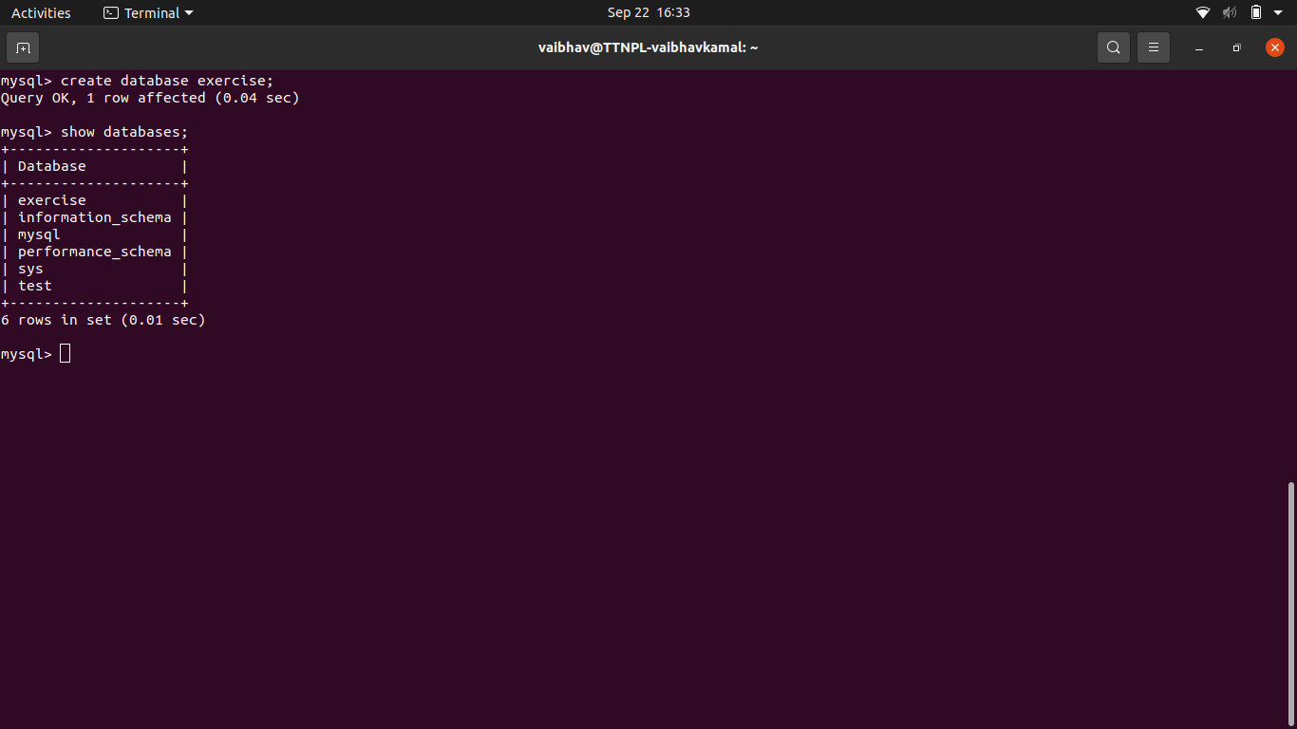
2. **Design Schema** 
   1. 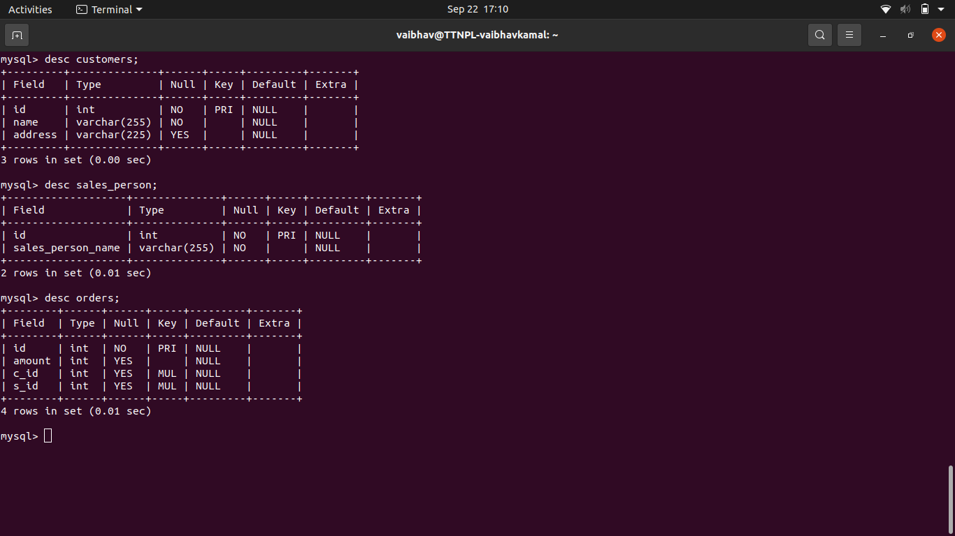
3. **Create tables** 
   1. Customer = create table customers (id int not null primary key,name varchar(255) not null, address varchar(225));
   2. Sale table = create table sales_person (id int not null primary key,sales_person_name varchar(255) not null)
   3. Orders Table = create table orders(id int primary key,amount int,c_id int,s_id int, constraint fk_customer foreign key(c_id) references customers(id), constraint foreign key(s_id) references sales_person(id));
   4. 
4. **Insert sample data** 
   1. **Insert into sale_person values**

**(1,’ram’),**

**(2,’kumari’),**

**(3,’seta’),**

**(4,’vikash’),**

**(5,’gopi’),**

**(6,’geta’);**

* 1. **Insert into customer values**

**(1,’vaibhav’,’kanpur’),**

**(2,’kamal’,’kanpur’),**

**(3,’ramtari’,’mp’),**

**(4,’naveen’,’gaya’),**

**(5,’nitin’,’kanpur’),**

**(6,’kumar’,’kanpur’),**

**(7,’mohit’,’dehli’);**

* 1. **Insert into orders values**

**(101,2523,1,3),**

**(102,505,2,4),**

**(103,500,3,1),**

**(104,670,3,2),**

**(105,574,6,6),**

**(106,600,5,5),**

**(107,2523,6,3),**

**(108,2523,5,4),**

**(109,2323,2,3);**

* 1. 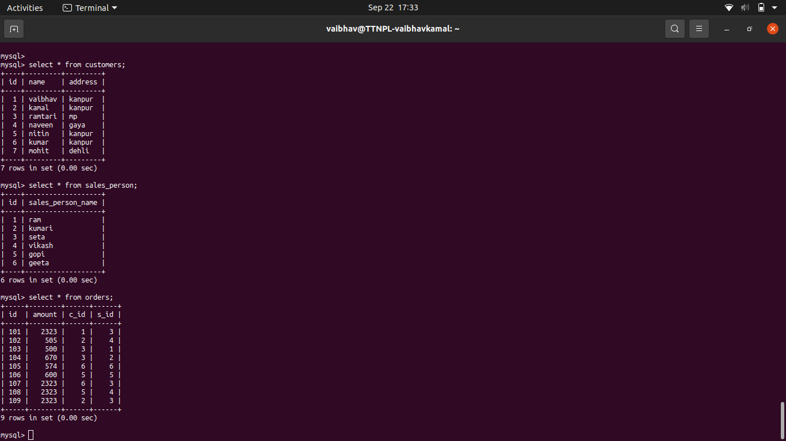

1. **Find the sales person have multiple orders.** 
   1. select s.sales_person_name from sales_person s inner join orders o on s.id = o.s_id group by s.sales_person_name having count(s.sales_person_name)>1;
   2. 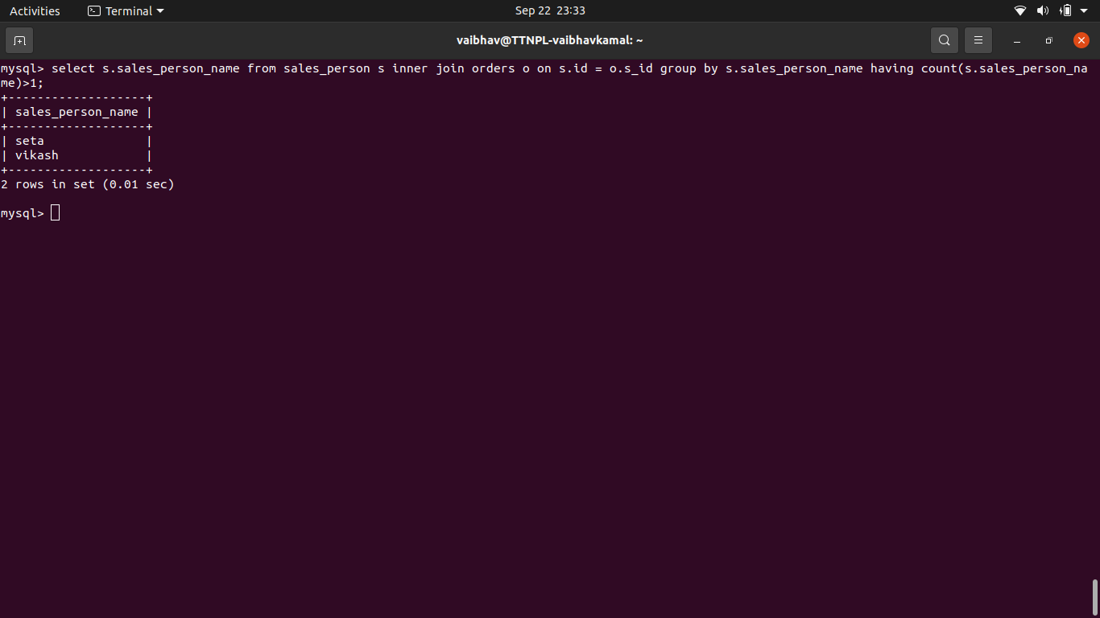
2. **Find the all sales person details along with order details**
   1. **select * from sales_person s inner join orders o on s.id = o.s_id;**
   2. 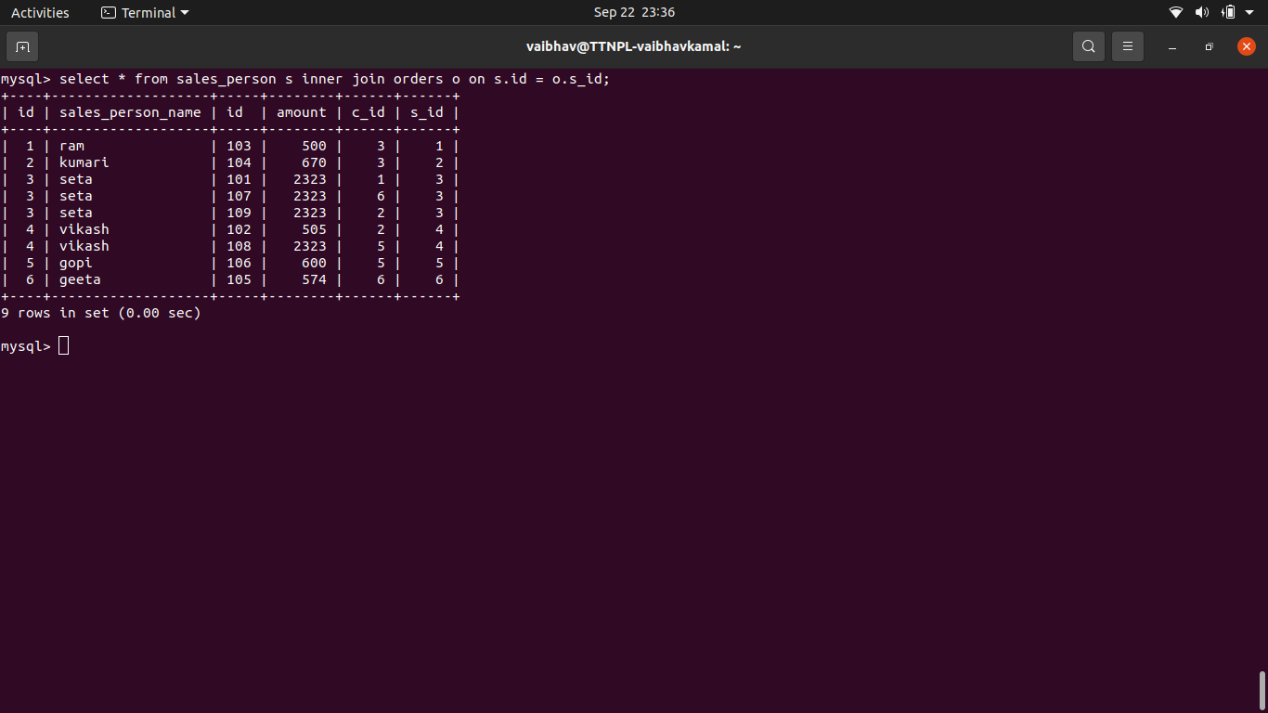
3. **Create index**
   1. create index my_index on orders(id);
   2. 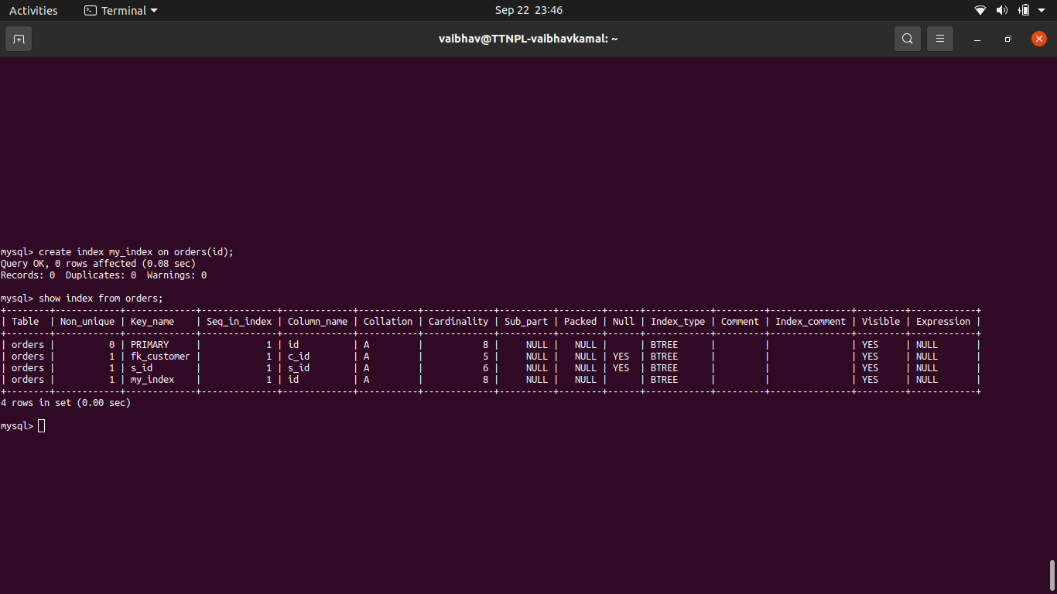
4. **How to show index on a table**
   1. show index from orders;
   2. 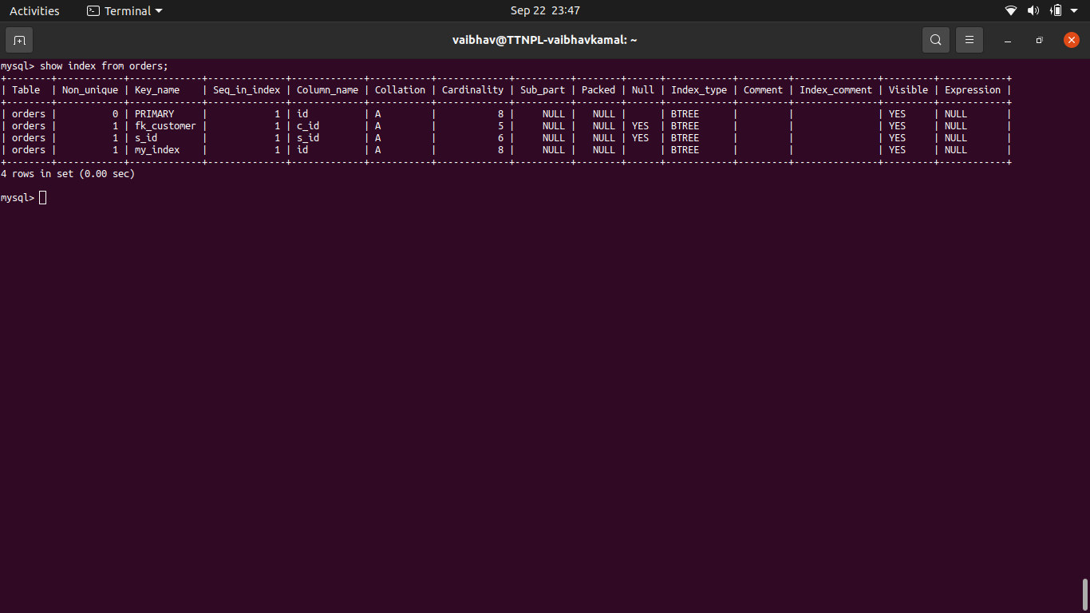
5. **Find the order number, sale person name, along with the customer to whom that order belongs to**
   1. select o.id,s.sales_person_name,c.name from orders o inner join sales_person s inner join customers c on o.s_id = s.id and o.c_id = c.id;
   2. 